# **u_4138585158_419625898&fm_253&fmt_auto&app_138&f_**

# **Graduation Certificate**

**LUO Wenjie**, **male**, born on **July 20, 2001**, studied a four-year program in **Digital Media Technology** at our school from **September 2019** to **June 2023**. Having completed all courses specified in the teaching plan and passed the examinations, he is allowed to graduate.（所标红的字体请根据实际情况填写）

School: **Hunan University of Science and Engineering** (Seal) President: **Li Gang**

Certificate No.: 105511202305002602 June 29th, 2023

Academic credentials inquiry website of the Ministry of Education of P.R.C: [h](http://www.chsi.com.cn)[ttp://www.chsi.](http://www.chsi.com.cn)[com.cn](http://www.chsi.com.cn)

**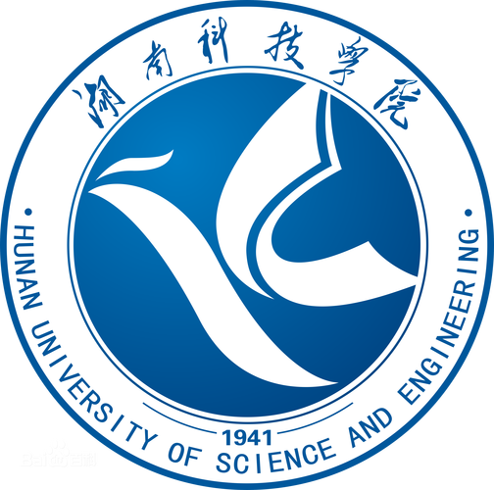**

**Bachelor’s Degree Certificate**

This is to certify that **LUO Wenjie, male,** born on **July 20, 2001**, studied in **Hunan University of Science and Engineering**, from **September 2019** to **June 2023**, majoring in **Digital Media Technology**, and completed the requirements of an undergraduate program with satisfactory results. According to *Regulations of the People’s Republic of China on Academic Degrees*, he is awarded the degree of Bachelor of **Engineering**.（所标红的字体请根据实际情况填写）

## **Hunan University of Science and Engineering** (Seal)Chairman of the Academic Evaluation Committee: **Li Gang**

Certificate No.: 1055142023002602 June 29th, 2023

**(Undergraduate of Ordinary Higher Education)**